#
# 20200124
#
simpana list ; simpana status ; simpana stop ; simpana start ; simpana list ; simpana status

#
# 20190704
# SD#2872032
# Needs get status simpana, stop it, start it.

# On one server I’ve received error: “There is already another simpana running”.

[support@centos ~]$ ansible all -i /tmp/list_of_hosts -m shell -a "hostname ; simpana stop ; simpana start" --become --extra-vars "ansible_user=bsv ansible_password=$(pass common/linux) ansible_sudo_pass=$(pass common/linux) ansible_ssh_common_args='-oStrictHostKeyChecking=no -oPubkeyAuthentication=no'"
m1-sasfront02p | FAILED | rc=1 >>
m1-sasfront02p
*** There is already another simpana running.
*** There is already another simpana running.non-zero return code

m1-asterisk-str01p | SUCCESS | rc=0 >>
m1-asterisk-str01p.tcsbank.ru
Stopping Simpana services for Instance001 ...
Cleaning up /opt/simpana/Base/Temp ...
Starting Simpana services for Instance001 ...

ds-informatica01t.ti-test.local | SUCCESS | rc=0 >>
ds-informatica01t.ti-test.local
Stopping Commvault services for Instance002 ...
Cleaning up /var/log/simpana2/Log_Files/locks ...
Cleaning up /opt/simpana2/Base/Temp ...
Starting Commvault services for Instance002 ...

ds-asterisk-str01p | SUCCESS | rc=0 >>
ds-asterisk-str01p.tcsbank.ru
Stopping Commvault services for Instance001 ...
Cleaning up /var/log/simpana/Log_Files/locks ...
Cleaning up /opt/simpana/Base/Temp ...
Starting Commvault services for Instance001 ...

[support@centos ~]$
[support@centos ~]$ cat /tmp/list_of_hosts
m1-asterisk-str01p
m1-sasfront02p
ds-asterisk-str01p
ds-informatica01t.ti-test.local
# ds-informatica01p
[support@centos ~]$

[root@m1-sasfront02p ~]# simpana stop
*** There is already another simpana running.
[root@m1-sasfront02p ~]#

[root@m1-sasfront02p ~]# simpana list

*** Instance001, cv-comsrv ***
+-----------+---------+--------------------------------------------------------+
| Service | PID | Description |
+-----------+---------+--------------------------------------------------------+
| cvlaunchd | N/A | Commvault Launch Daemon |
+-----------+---------+--------------------------------------------------------+
| cvd | N/A | Commvault Communications Service |
+-----------+---------+--------------------------------------------------------+
| ClMgrS | N/A | Commvault Client Event Manager |
+-----------+---------+--------------------------------------------------------+
You have new mail in /var/spool/mail/root
[root@m1-sasfront02p ~]#

[root@m1-sasfront02p ~]# whereis simpana
simpana: /usr/bin/simpana
[root@m1-sasfront02p ~]# grep -ie "There is already another simpana running" /usr/bin/simpana
[ -f /tmp/.lock_Galaxy ] && echo "*** There is already another simpana running." && exit 1
[root@m1-sasfront02p ~]#

[root@m1-sasfront02p ~]# rm /tmp/.lock_Galaxy
rm: remove regular empty file `/tmp/.lock_Galaxy'? y
[root@m1-sasfront02p ~]#

[root@m1-sasfront02p ~]# simpana stop
Stopping Commvault services for Instance001 ...
[root@m1-sasfront02p ~]# simpana start
Cleaning up /opt/simpana/Base/Temp ...
Starting Commvault services for Instance001 ...
[root@m1-sasfront02p ~]#

[support@centos ~]$ ansible all -i /tmp/list_of_hosts -m shell -a "hostname ; simpana list ; simpana status" --become --extra-vars "ansible_user=bsv ansible_password=$(pass common/linux) ansible_sudo_pass=$(pass common/linux) ansible_ssh_common_args='-oStrictHostKeyChecking=no -oPubkeyAuthentication=no'"
m1-sasfront02p | SUCCESS | rc=0 >>
m1-sasfront02p

*** Instance001, cv-comsrv ***
+-----------+---------+--------------------------------------------------------+
| Service | PID | Description |
+-----------+---------+--------------------------------------------------------+
| cvlaunchd | 22305 | Commvault Launch Daemon |
+-----------+---------+--------------------------------------------------------+
| cvd | 22312 | Commvault Communications Service |
+-----------+---------+--------------------------------------------------------+
| ClMgrS | 22318 | Commvault Client Event Manager |
+-----------+---------+--------------------------------------------------------+
--------------------------------- Instance001 ---------------------------------
[ General ]
Version = 11(BUILD80) SP7
CommServe = cv-comsrv.tcsbank.ru
Home Directory = /opt/simpana/Base
Log Directory = /var/log/simpana/Log_Files
Core Directory = /opt/simpana
Temp Directory = /opt/simpana/Base/Temp
Platform Type = 4
Cvd Port Number = 8400
[ Package ]
1002/CVGxBase 11(BUILD80) = File System Core
1101/CVGxIDA = File System
[ Physical Machine/Cluster Groups ]
Display Name = m1-sasfront02p
- Client Hostname = m1-sasfront02p.tcsbank.ru
- Job Results Directory = /opt/simpana/iDataAgent/jobResults

ds-asterisk-str01p | SUCCESS | rc=0 >>
ds-asterisk-str01p.tcsbank.ru

*** Instance001, cv-comsrv ***
+-----------+---------+--------------------------------------------------------+
| Service | PID | Description |
+-----------+---------+--------------------------------------------------------+
| cvlaunchd | 155863 | Commvault Launch Daemon |
+-----------+---------+--------------------------------------------------------+
| cvd | 155864 | Commvault Communications Service |
+-----------+---------+--------------------------------------------------------+
| ClMgrS | 155865 | Commvault Client Event Manager |
+-----------+---------+--------------------------------------------------------+
| cvfwd | 155869 | Commvault FireWall Daemon |
+-----------+---------+--------------------------------------------------------+
| CvMountd | 155867 | Commvault Media Mount Manager |
+-----------+---------+--------------------------------------------------------+
--------------------------------- Instance001 ---------------------------------
[ General ]
Version = 11(BUILD80) SP9
CommServe = cv-comsrv.tcsbank.ru
Home Directory = /opt/simpana/Base
Log Directory = /var/log/simpana/Log_Files
Core Directory = /opt/simpana
Temp Directory = /opt/simpana/Base/Temp
Platform Type = 6
Cvd Port Number = 8400
[ Package ]
1002/CVGxBase 11(BUILD80) = File System Core
1101/CVGxIDA = File System
1301/CVGxMA = MediaAgent
[ Physical Machine/Cluster Groups ]
Display Name = ds-asterisk-str01p
- Client Hostname = ds-asterisk-str01p
- Job Results Directory = /opt/simpana/iDataAgent/jobResults
- Index Cache Directory = /opt/simpana/MediaAgent/IndexCache
...

#
# 20190411
# Simpana agent was not work properly.
# Eralnov asked to stop and start it first.
#
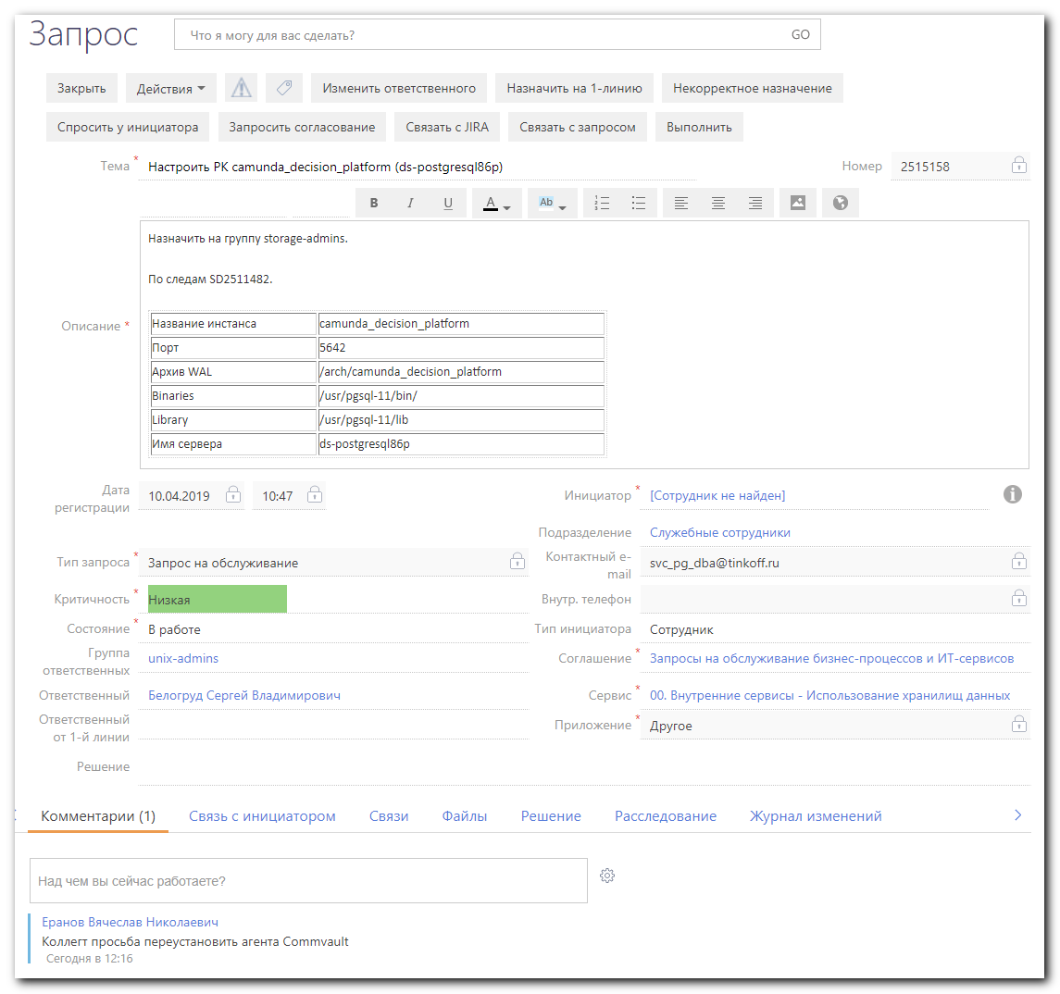

[root@ds-postgresql86p ~]# commvault stop
Redirecting stopping service for Instance001 to systemd ...
Running "systemctl stop commvault.Instance001.service" ...
[root@ds-postgresql86p ~]# commvault status
--------------------------------- Instance001 ---------------------------------
[ General ]
Version = 11(BUILD80) SP12 (1303739)
CommServe = cv-comsrv
Home Directory = /opt/commvault/Base
Log Directory = /var/log/commvault/Log_Files
Core Directory = /opt/commvault
Temp Directory = /opt/commvault/Base/Temp
Platform Type = 4
Cvd Port Number = 8401
[ Package ]
1002/CVGxBase 11(BUILD80) = File System Core
1101/CVGxIDA = File System
1209/CVGxPostGres = PostGres iDataAgent
[ Physical Machine/Cluster Groups ]
Display Name = ds-postgresql86p
- Client Hostname = ds-postgresql86p.tcsbank.ru
- Job Results Directory = /opt/commvault/iDataAgent/jobResults
[root@ds-postgresql86p ~]# commvault start
Redirecting starting service for Instance001 to systemd ...
Running "systemctl start commvault.Instance001.service" ...
[root@ds-postgresql86p ~]# commvault status
--------------------------------- Instance001 ---------------------------------
[ General ]
Version = 11(BUILD80) SP12 (1303739)
CommServe = cv-comsrv
Home Directory = /opt/commvault/Base
Log Directory = /var/log/commvault/Log_Files
Core Directory = /opt/commvault
Temp Directory = /opt/commvault/Base/Temp
Platform Type = 4
Cvd Port Number = 8401
[ Package ]
1002/CVGxBase 11(BUILD80) = File System Core
1101/CVGxIDA = File System
1209/CVGxPostGres = PostGres iDataAgent
[ Physical Machine/Cluster Groups ]
Display Name = ds-postgresql86p
- Client Hostname = ds-postgresql86p.tcsbank.ru
- Job Results Directory = /opt/commvault/iDataAgent/jobResults
[root@ds-postgresql86p ~]#

#
# To remove simpana commvault need to run cvpkgrm and select remove everything, that this utility can.
#
[root@ds-postgresql86p ~]# find /opt/commvault/ -iname *cvpkgrm*
/opt/commvault/installer/cvpkgrm
/opt/commvault/Base64/cvpkgrm
/opt/commvault/cvpkgrm
/opt/commvault/CVMedia/11.0.0/Unix/linux-x8664/linux-glibc2.3-x86_64/BinaryPayLoad/cvpkgrm.gz
[root@ds-postgresql86p ~]#

